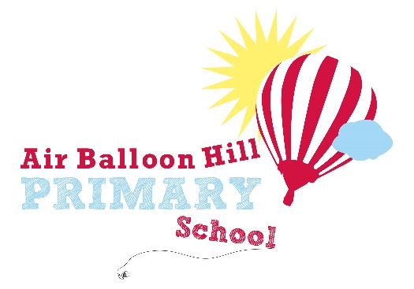

Back to School Workbook
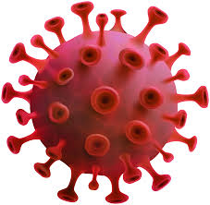

This workbook will help you think about your time at home and about going back to school

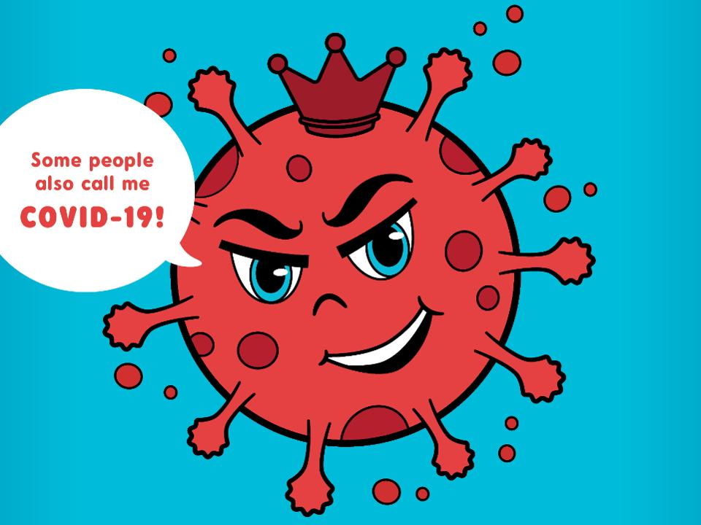
Lots of people have been talking about coronavirus. What do you know about Coronavirus? Write or draw what you know here.

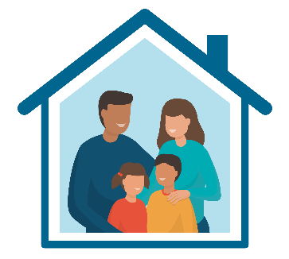
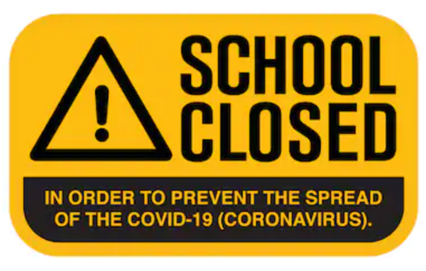
Schools have been closed to most children to keep them safe at home and to stop the spread of coronavirus.
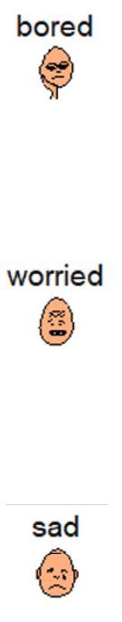
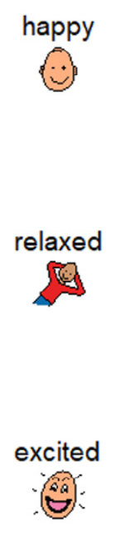
Think about your time at home. What feelings did you have?

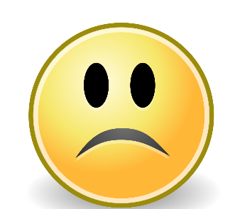
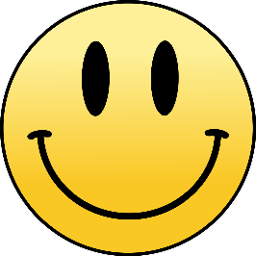

What didn’t you like about being at home? Write or draw here.
What were your favourite things about being at home? Write or draw them here.

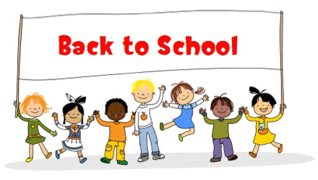
The government have been deciding when it is safe for children to go back to school.
We might have lots of feelings about going back to school. Write or draw them here.

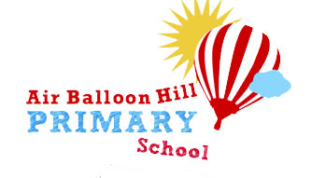
Who are you looking forward to seeing?
What are you looking forward to doing?

There are lots of good things about going back to school.

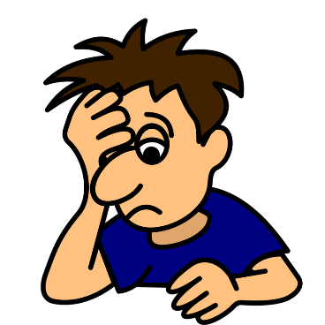
It’s okay to have some worries about going back to school.
It’s important that you talk about your worries with a trusted adult as this will make you feel better.

Who are your trusted adults? Write or draw them here.
Do you have any worries? Write or draw them here.
Staying Safe in School
When you return to school things might look a little different so that we can keep everyone safe. There may be some new rules that are important to follow. Mr Browse and your teacher will send you some information to show you what school will be like.

There are lots of things that we can do to make sure we are safe and healthy when you come back to school.
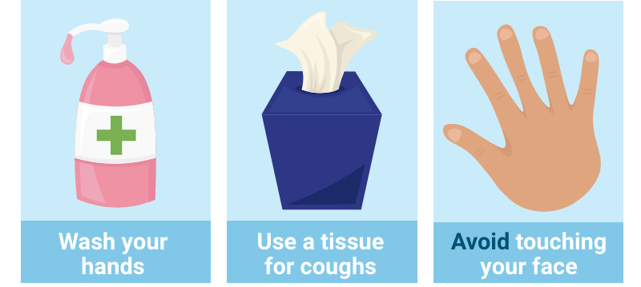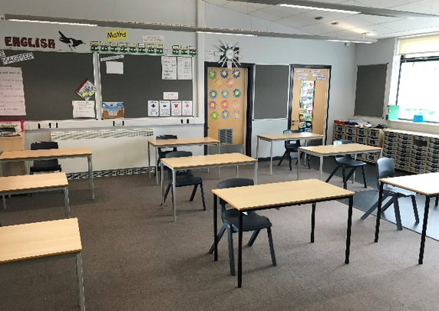

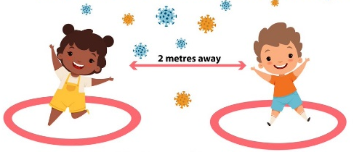
Most children have been at home for a long time and haven’t been able to see their friends. When we go back to school, our class will be smaller than normal and will be called ‘a bubble’.
We can only spend time with the other children in our bubble and we need to remember that we can’t hug our friends or teachers yet. This will keep everyone safe.
Write or draw the things you want to talk about to your friends.
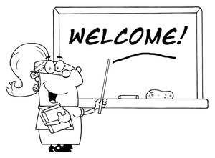
You might have a different teacher when you come back to school. This is because our bubbles (classes) have to be much smaller to keep everyone safe so your teacher can’t be with everyone. Although your teacher will miss you, your new teacher will be very pleassed to have you in their class. You might also be learning in a different classroom.

My teacher will be …………………………………………….
My classroom will be ………………………………….........
Write or draw the things you want to tell your teacher.

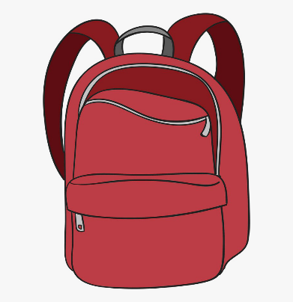
When you go back to school, it is important that you wear clean clothes every day. This means that you don’t have to wear your school uniform.
You won’t be able to bring many things in from home apart from a water bottle (this is very important) and a packed lunch if you will be having one.
Draw yourself on your first day back at school.
You can write down any questions you have about what school will be like here.
You can talk to your someone at home or at school about them before you return.

We can’t wait to see you again soon!

